**Name Damien Mc Geehan**

|  |  |  |  |  |  |
| --- | --- | --- | --- | --- | --- |
| Document Name: | Movie Theatre Management System | Document ID: | | Popcorn001 | |
| Date First Published: | 05/06/2017 | Version Number: | | 1 | |
| Status: |  | Authorised By: Paul Herron | | | |
| Author | Damien Mc Geehan | Authorisation Date | 05/06/2017 | | |
| Approval |  | Approved by: Paul Herron  Date: 05/06/2017 | | | |
| Updates: |  |  | |  | |
| Update Date | Update Reason | Author(s) | | Approved By | Approval Date |
|  |  |  | |  |  |
|  |  |  | |  |  |
|  |  |  | |  |  |

**Hardware Specification**

|  |  |  |
| --- | --- | --- |
| **Hardware Specification** |  |  |
| **Description** | **Quantity** | **Cost** |
| **Hard Drive Server (Storinator x2 q30 3.100 + 8tb hard drive (WD gold enterprise high load drive))** | **2** | **£500** |
| **Net Gear and Net Switches** | **10** | **£160** |
| **Zoostorm Evolve Desktop Pc Core i5 – 6400 16gb 2 tb Windows 10 - Professional £509.25 80** | **7** | **£509.25** |
| **Network Cables, £0.80 cent each X 400** | **40** | **£0.80** |
| **U.P.S(Uninterruptable Power Supply) £180 each** | **1** | **£180** |
| **Ticket Scanner x £20 X 80 each** | **4** | **£20** |
| **Monitor £100 each x 80** | **7** | **£100** |
| **10 HP LaserJet Enterprise 700 Printer specifications £5000 euro each** | **1** | **£5000** |
| **Mouse and keyboards X 8010 each** | **7** | **£10** |
| **Ticket Printer AMT Datasouth E-Data 7200** | **4** | **£180** |

**Software Specification**

|  |
| --- |
| **Windows 10** |
| **Supports .NET Framework** |
| **Microsoft SQL Connect** |
| **Network Access** |

**Minimum**

|  |
| --- |
| **Windows 7** |
| **2GB Ram** |
| **Core i3** |
| **3 Ghz Dualcore** |

**Associated error messages:**

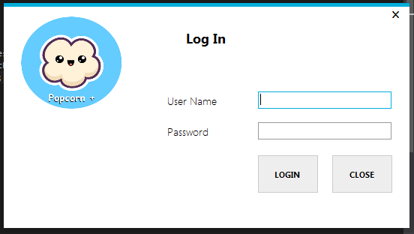

**Error 001: Invalid Username or Password**

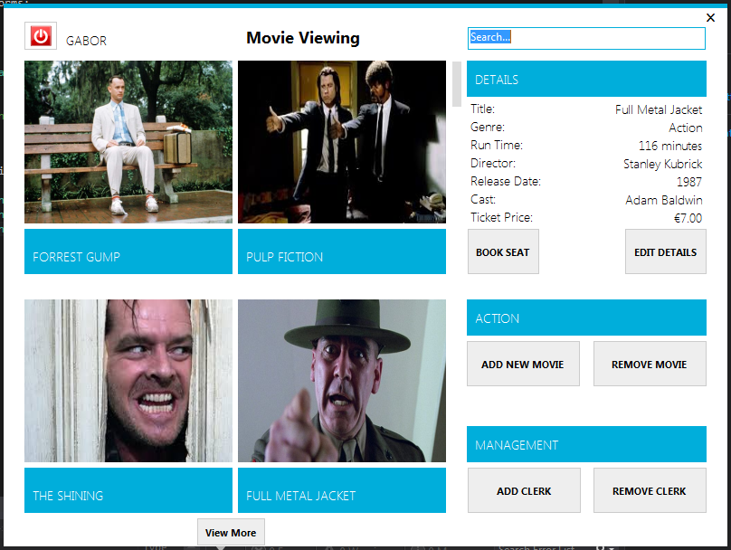

**Error 002: User Does Not Have Add Movie Privilege**

**Error 003: User Does Not Have Remove Movie Privilege**

**Error 004: User Does Not Have Add Clerk Privilege**

**Error 005: User Does Not Have Remove Clerk Privilege**

**Error 006: User Does Not Have Edit Details Privilege**

**Error 007: Invalid Search – No Match**

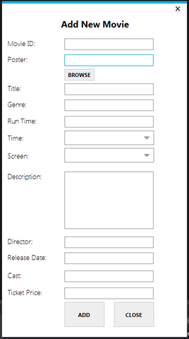

**Error 009: Movie I.D. Already Exists**

**Error 010: Invalid File Type for Poster**

**Error 011: Invalid File Does Not Exist**

**Error 012:**

**Error 013:**

**Error 014:**

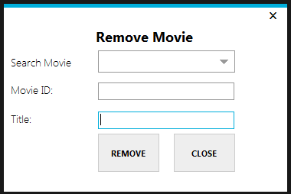

**Error 015:**

**Error 016:**

**Error 017:**

**Error 018:**

**Error 019:**

**Error 020:**

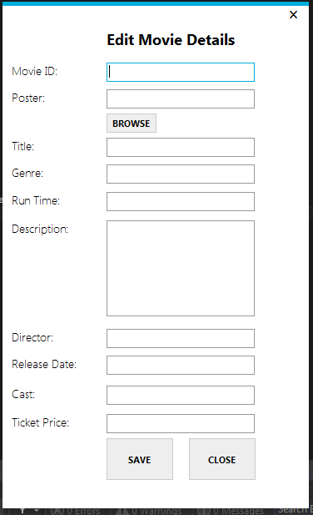

**Error 021:**

**Error 022:**

**Error 023:**

**Error 024:**

**Error 025:**

**Error 026:**

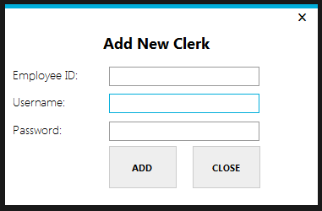

**Error 026: Invalid Username or Password Length – Must be less than 11 Characters**

**Error 027:**

**Error 028:**

**Error 029:**

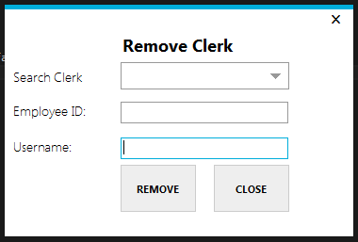

**Error 031:**

**Error 032:**

**Error 033:**

**Error 034:**

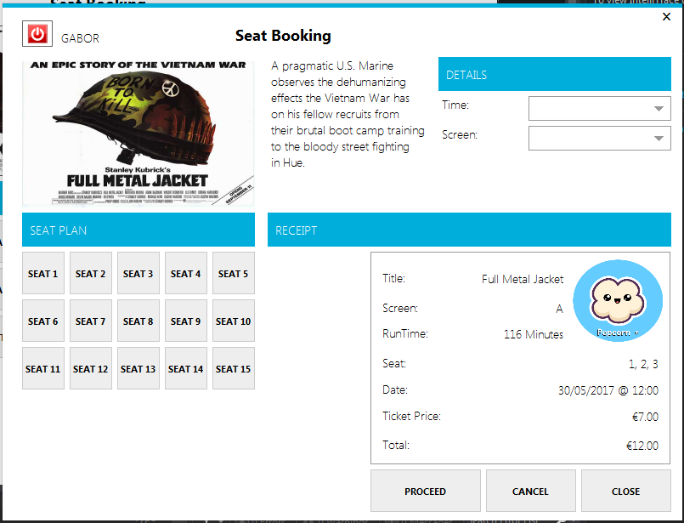

**Error 035:**

**Error 036:**

**Error 037:**

**Error 038:**

**Error 039:**

**Error 040:**

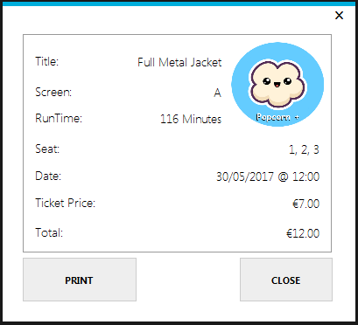

**Error 040:**

**Error 041:**

**Error 042:**

**File and Print Layouts**

|  |  |  |  |
| --- | --- | --- | --- |
| **Movie Theatre Management System** | | **Movie I.D:** |  |
| **Ticket** | |
|  | |
| **Ticket #** | **999999999** | **Seat** | **35L** |
| **Movie Name:** |  | **Genre** |  |
| **Screen #** |  | **Movie Time** | **13:45** |
| **Date:** | **05/06/2016** | | |
| **Price** | **€100.00** | | |

**Input and Output Data Specifications**

Pseudocode

**Security Measures**

**Backup**

Backup files will be stored at the end of each day.

**Passwords**

A login function will be used to access the system. The user will be allowed 2 attempts to enter the correct password. If the user enters the wrong credentials twice it will then be sent to the Administrator who will then have to enter their details to unlock the users account to allow them to complete their work.

**Health and Safety**

I am fully aware of all health and safety requirements for this course to ensure the safety of my fellow students.